

User Research Report and Personas

Project Name | Project Group Members: Member 1, Member 2, Member 3, Member 4

INFO 200 Problem Statement | Section Name | TA Name

**Table of Contents**

**Problem Brief** (~50 words) **2**

**Existing Solutions** **2**

Existing Solution 1 (~200 words) 2

Existing Solution 2 (~200 words) 2

Existing Solution 3 (~200 words) 3

**Stakeholder Groups** **4**

Stakeholder 1 (~100 words) 4

Stakeholder 2 (~100 words) 4

Stakeholder 3 (~100 words) 4

**User Research** **5**

Surveys 6

Interviews 7

Stakeholder Interview 7

User Interview 1 7

User Interview 2 7

**User Personas** **8**

**Conclusion** (~100 words) **10**

**Bibliography** **10**

**Appendix** **10**

Interview Notes 10

Survey Results 10

* **In this assignment, you are not supposed to discuss your proposed solution. Focus only on your research in this deliverable.**
* Please review the [Documentation Guidelines](https://docs.google.com/a/uw.edu/document/d/1WlhpcwT7Jv36nMkrBkGhxxm1igfnsm5MoMYwZ3t_fZA/edit?usp=drive_web) before starting

# Problem Brief (~ 50 words)

Just a short brief on your problem space and why you are solving it.

Lorem ipsum dolor sit amet, consectetur adipiscing elit. Etiam viverra varius sapien id egestas. Quisque et dapibus purus. Duis gravida turpis imperdiet, vestibulum tortor sed, bibendum diam. Donec eu auctor mauris. Cras feugiat urna quis urna lobortis tincidunt. Sed tincidunt facilisis porttitor. Ut mattis ante a posuere lobortis.

# Existing Solutions

Once you've identified a particular problem area, do some research to discover any existing solutions that might already be out there. These solutions might be things that your target group is already using but find inadequate or solutions to different but related problems that could give you some inspiration.

## Existing Solution 1 (~200 words)

* What does this service do? Why do people use it?
* Website Link to the service (if there is any).
* What does it do well?
* Where does it fall short?
* Are there any news articles discussing this service
* Put an image/screenshot of the website/app/software
* If there is an issue related to their solution remember to annotate the screenshot or put a caption highlighting it.

## Existing Solution 2 (~200 words)

* What does this service do? Why do people use it?
* Website Link to the service (if there is any).
* What does it do well?
* Where does it fall short?
* Are there any news articles discussing this service
* Put an image/screenshot of the website/app/software
* If there is an issue related to their solution remember to annotate the screenshot or put a caption highlighting it.

## Existing Solution 3 (~200 words)

* What does this service do? Why do people use it?
* Website Link to the service (if there is any).
* What does it do well?
* Where does it fall short?
* Are there any news articles discussing this service
* Put an image/screenshot of the website/app/software
* If there is an issue related to their solution remember to annotate the screenshot or put a caption highlighting it.

In addition, you may use a table to compare the existing solutions against each other.

|  |  |  |  |
| --- | --- | --- | --- |
|  | **Existing Solution 1** | **Existing Solution 2** | **Existing Solution 3** |
| **What does the existing solution do well?** |  |  |  |
| **Where does the existing solution fall short?** |  |  |  |
| **How are they similar?** |  |  |  |

# 

# Stakeholder Groups

For any given problem, there will likely be a few different social groups that have a "stake" in any solution you might design. These are groups that would either directly use your solution (direct stakeholders) or groups who might not use your solution but would nevertheless be affected by its use (indirect stakeholders). Think about what sort of people would use your solution or be affected by it, and go research them.

## Stakeholder 1 (~100 words)

Lorem ipsum dolor sit amet, consectetur adipiscing elit. Quisque quis ipsum auctor, rhoncus purus quis, cursus massa. Morbi vel rhoncus nunc, nec luctus nibh. Nunc eleifend posuere elit ac porttitor. Curabitur efficitur tristique mattis. Curabitur finibus leo et faucibus vestibulum. Pellentesque et nunc sagittis, bibendum erat fringilla, tincidunt justo. Mauris volutpat vulputate pulvinar. Duis at facilisis lorem, id mollis urna. Mauris gravida non libero a eleifend. Aenean porttitor velit lectus, sed sagittis dolor ullamcorper a. Vestibulum id tincidunt nisl. Proin augue quam, vulputate vitae diam eu, aliquam venenatis quam. Fusce sit amet aliquet dolor. In tempus, leo vel pulvinar pharetra.

## Stakeholder 2 (~100 words)

Lorem ipsum dolor sit amet, consectetur adipiscing elit. Quisque quis ipsum auctor, rhoncus purus quis, cursus massa. Morbi vel rhoncus nunc, nec luctus nibh. Nunc eleifend posuere elit ac porttitor. Curabitur efficitur tristique mattis. Curabitur finibus leo et faucibus vestibulum. Pellentesque et nunc sagittis, bibendum erat fringilla, tincidunt justo. Mauris volutpat vulputate pulvinar. Duis at facilisis lorem, id mollis urna. Mauris gravida non libero a eleifend. Aenean porttitor velit lectus, sed sagittis dolor ullamcorper a. Vestibulum id tincidunt nisl. Proin augue quam, vulputate vitae diam eu, aliquam venenatis quam. Fusce sit amet aliquet dolor. In tempus, leo vel pulvinar pharetra.

## Stakeholder 3 (~100 words)

Lorem ipsum dolor sit amet, consectetur adipiscing elit. Quisque quis ipsum auctor, rhoncus purus quis, cursus massa. Morbi vel rhoncus nunc, nec luctus nibh. Nunc eleifend posuere elit ac porttitor. Curabitur efficitur tristique mattis. Curabitur finibus leo et faucibus vestibulum. Pellentesque et nunc sagittis, bibendum erat fringilla, tincidunt justo. Mauris volutpat vulputate pulvinar. Duis at facilisis lorem, id mollis urna. Mauris gravida non libero a eleifend. Aenean porttitor velit lectus, sed sagittis dolor ullamcorper a. Vestibulum id tincidunt nisl. Proin augue quam, vulputate vitae diam eu, aliquam venenatis quam. Fusce sit amet aliquet dolor. In tempus, leo vel pulvinar pharetra.

# User Research

The next stage of your project is User Research. How you do your user research will depend on what problem you are trying to solve, and who your stakeholders are.

Here are some helpful Blog Articles we recommend to read before you start the assignment:

User Research Plans:

* <https://uxplanet.org/user-research-can-help-to-avoid-big-design-mistakes-d017239f1986>
* <https://uxdesign.cc/unmissable-steps-in-user-research-44650e891869>
* <https://uxplanet.org/how-to-choose-a-user-research-method-985112051d84>

Surveys & Stakeholder Interviews:

* <https://www.interaction-design.org/literature/article/how-to-conduct-user-interviews>
* <http://boxesandarrows.com/a-stakeholder-interview-checklist/>
* [https://www.quickanddirtytips.com/education/grammar/how-to-write-good-survey-questions](https://www.quickanddirtytips.com/education/grammar/how-to-write-good-survey-questions?ref=startupmate)

We are giving you a couple weeks to do this research because it may take you a few days to discover who you should talk with, and arrange meetings. Get started on this early, and do not wait until the last minute. The people you need to talk with may be quite busy.

## 

## Surveys

**We recommend using** [**Google Forms**](http://forms.google.com) **to make your surveys.**

Common ways to distribute surveys and collect responses are by sending emails, posting in Facebook groups/ Reddit/ Twitter, sending messages to friends, going in-person to locations where your stakeholders are present,

Paragraph 1: (~100 words)

* What was the purpose of the survey?
* Why was this research method appropriate?
* What were the Distribution Methods used? Why?
* What demographics were collected? Why?
* What were the Key Questions asked? Why?
* Link to the Survey Questions (ensure the link is working)
* Link to the Survey Results (ensure the link is working)

Paragraph 2: (~100 to 150 words)

* How many survey respondents did you get? What were their demographics?
* What key insights and learnings were gained? (ensure they are detailed)
* Please add any Graphs and Charts you think are appropriate

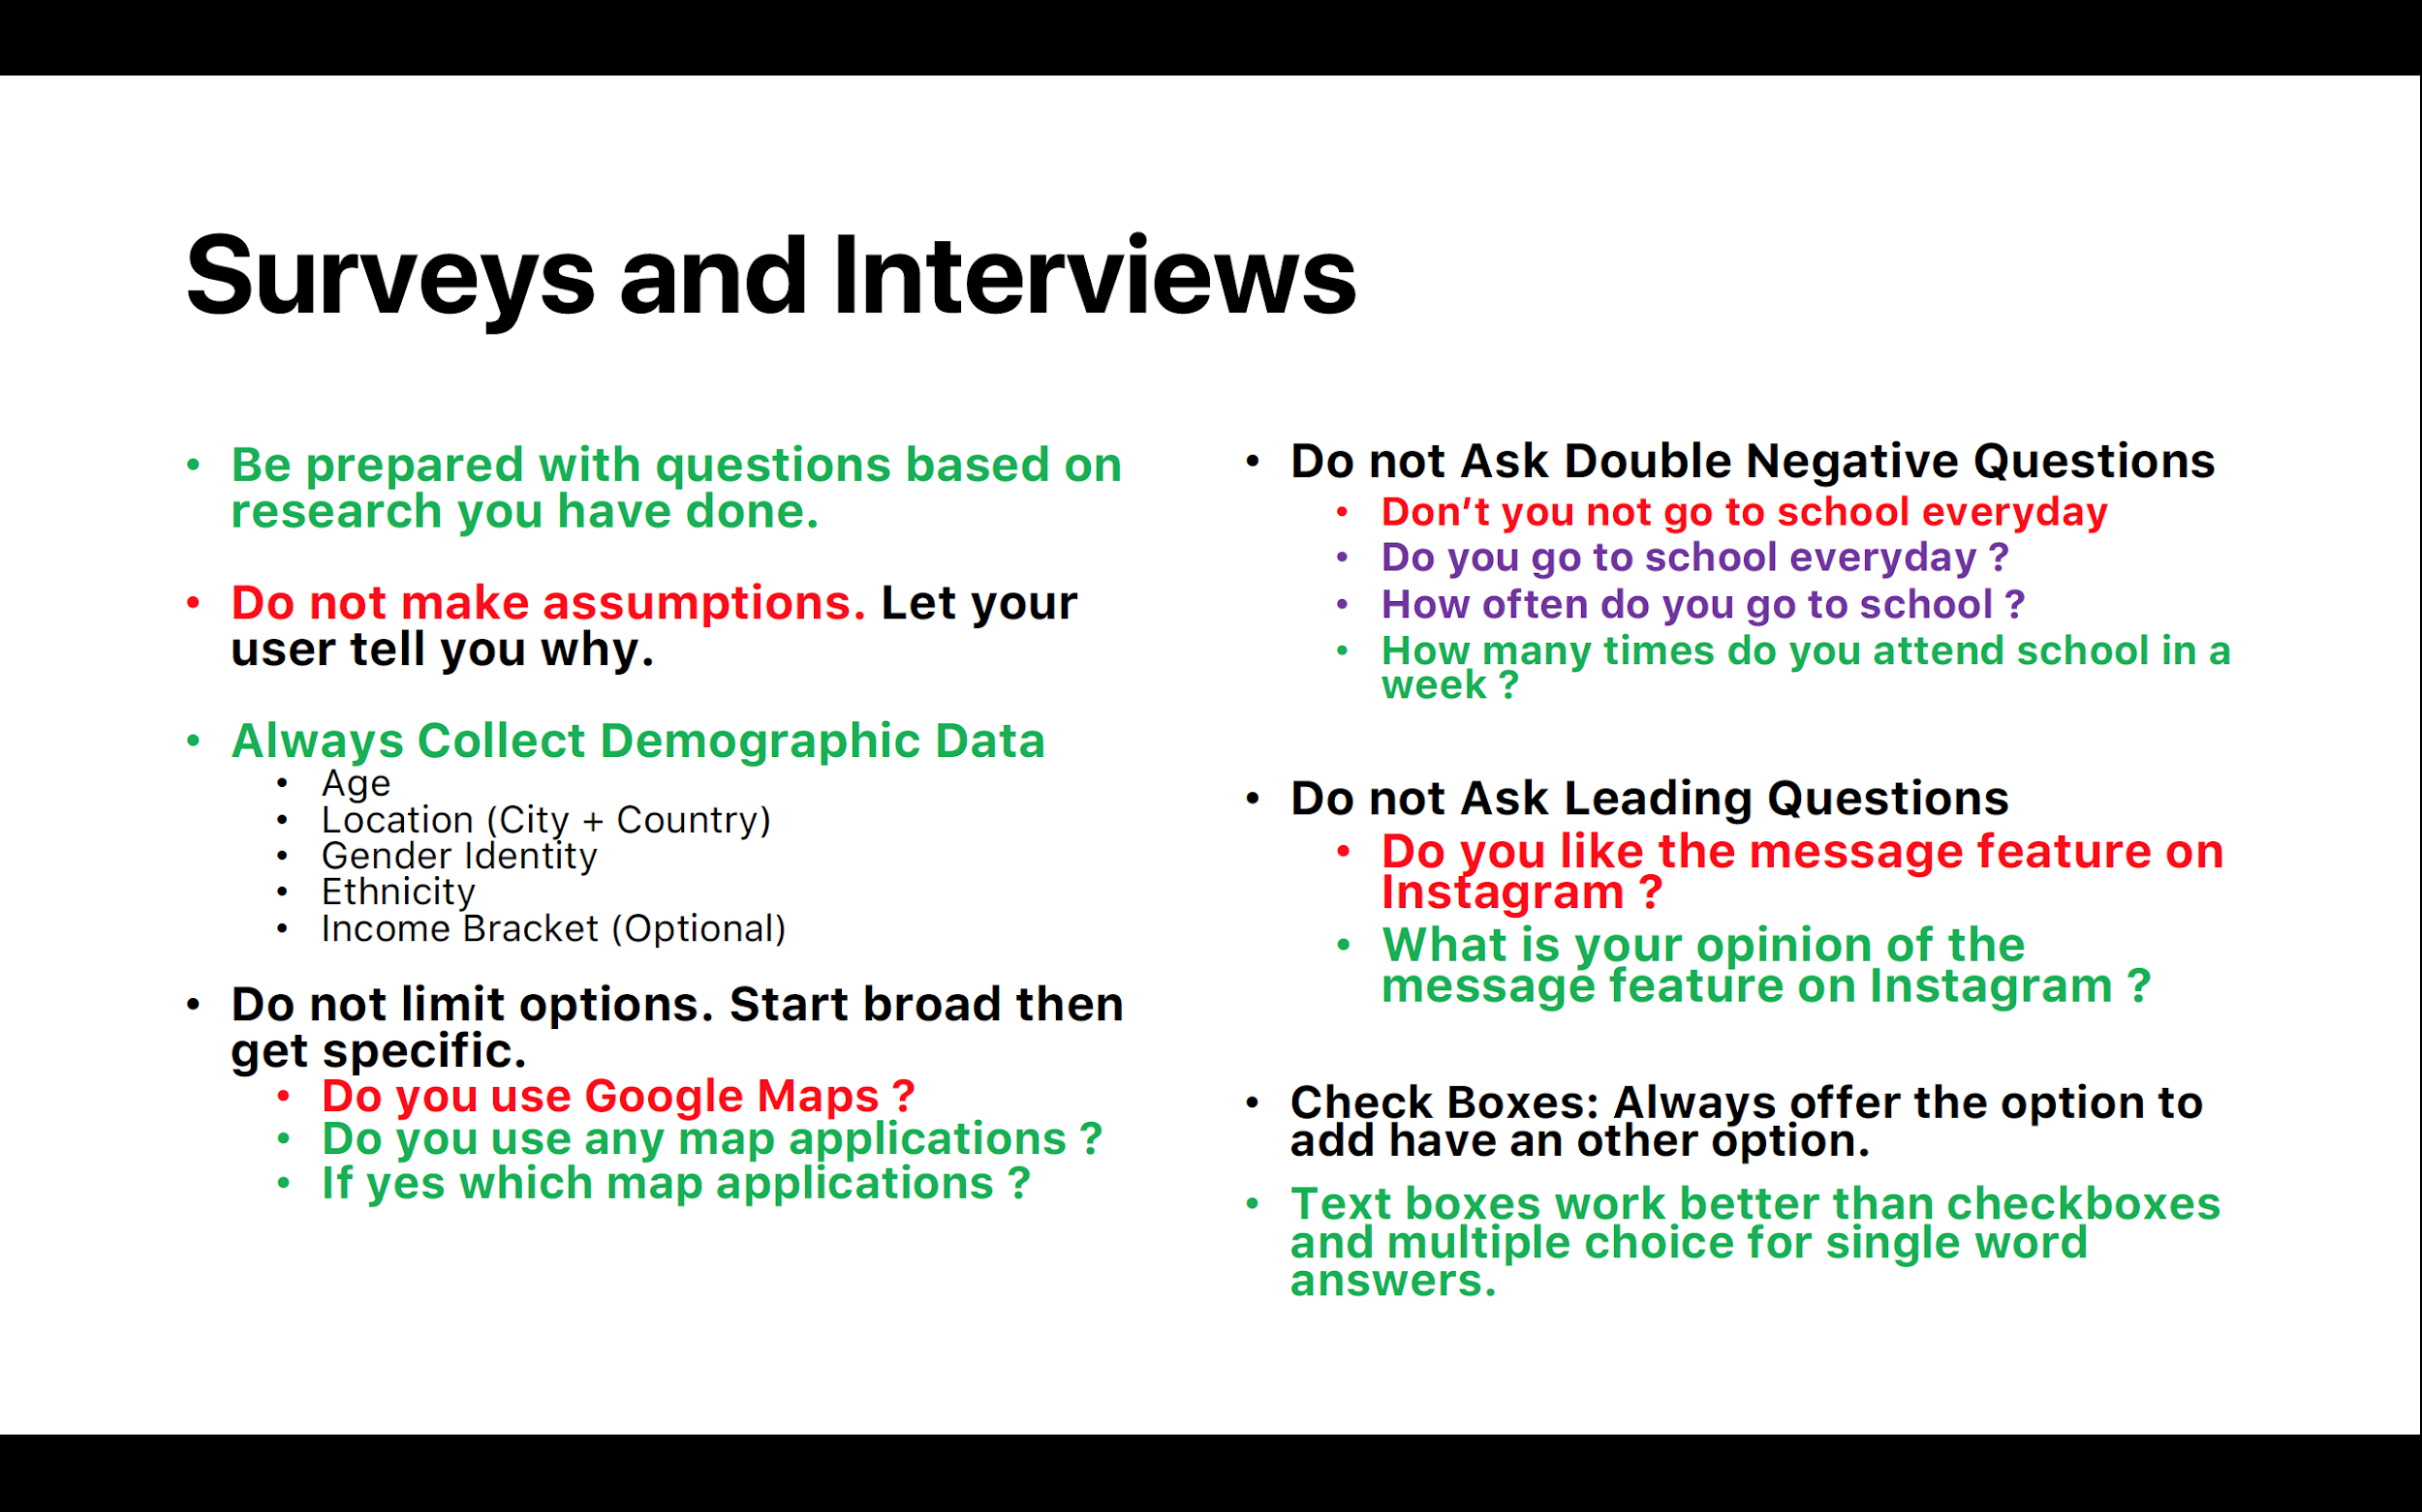

*Tips for Surveys and Interviews. Red questions indicate mistakes to avoid.*

## Interviews

**We recommend using** [**https://userbitapp.com/**](https://userbitapp.com/) **to take your stakeholder interview notes easily.**

### Stakeholder Interview

Paragraph 1: (~100 words)

* Who did you interview?
* What was the purpose of the interview?
* Why was this research method appropriate?
* What were the Key Questions asked? Why?

Paragraph 2: (~150 words)

* What key insights and learnings were gained? (you can list these but ensured they are detailed)
* Please add any Graphs and Charts as you think are appropriate

### User Interview 1

Paragraph 1: ( 100 words)

* Who did you interview?
* What was the purpose of the interview?
* Why was this research method appropriate?
* What were the Key Questions asked? Why?

Paragraph 2: (~150 words)

* What key insights and learnings were gained? (you can list these but ensured they are detailed)
* Please add any Graphs and Charts as you think are appropriate

### User Interview 2

Paragraph 1: (~100 words)

* Who did you interview?
* What was the purpose of the interview?
* Why was this research method appropriate?
* What were the Key Questions asked? Why?

Paragraph 2: (~150 words)

* What key insights and learnings were gained? (you can list these but ensured they are detailed)
* Please add any Graphs and Charts as you think are appropriate

# User Personas

After you've done your research, construct at least two user personas to represent the various kinds of stakeholders you will be serving. This article can help you with making your User Personas: [https://www.smashingmagazine.com/2014/08/a-closer-look-at-personas-part-1/](http://s.bl-1.com/h/cgkkKdkQ?url=https://www.smashingmagazine.com/2014/08/a-closer-look-at-personas-part-1/)

The way you approach creating your persona is up to you but here are some common elements of user personas. Please ensure your persona is not based on just your interactions with one person. This will make your persona skewed.

Select the fields most appropriate for representing your persona.

* Name
* Photo of the type of person they may look like
* Photos of them in the activities they do
* Age
* Occupation
* Bio
* Capabilities
* User Needs
* Frustrations
* Motivations
* Goals
* Tasks and Behavior
* Habits
* Daily Routine
* Family Style

**How to Make Persona Slides?**

* You can go to [https://xtensio.com/user-persona/](http://s.bl-1.com/h/cgkkKj6S?url=https://xtensio.com/user-persona/) to use their persona builder or use a software of your choice.
* You can also use these [persona templates](https://www.figma.com/file/iE9YEOezNYFi9wgHoQXfWX/user_persona_templates?node-id=0%3A1) made by Facebook and which can be imported and edited in [Figma](http://figma.com) (we’ll learn more about Figma later!)

Here are some creative ways through which user personas have been made and shown before.

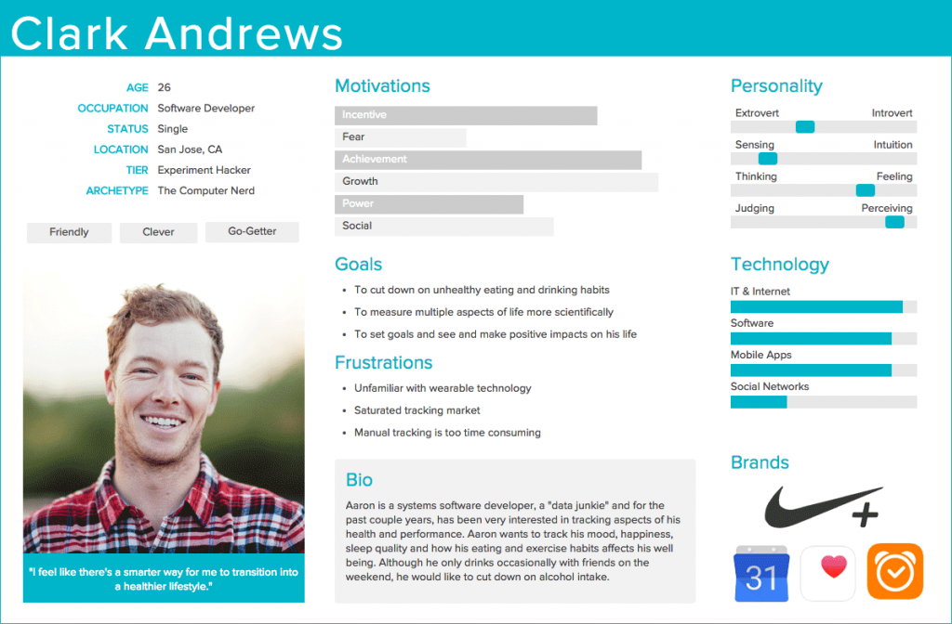

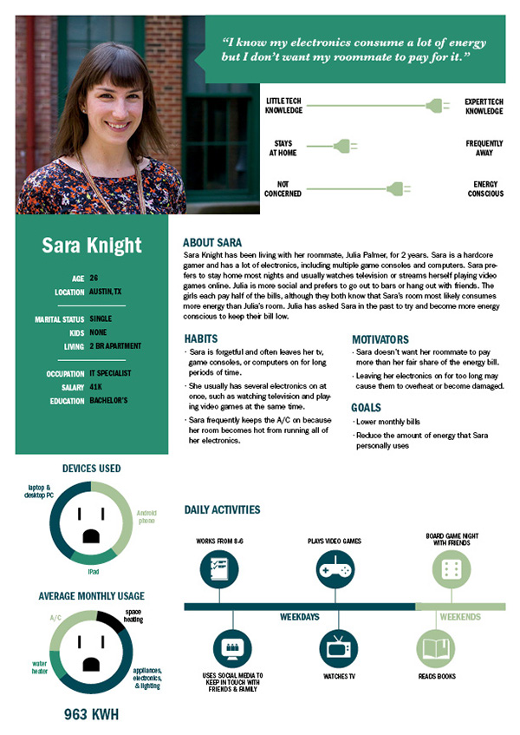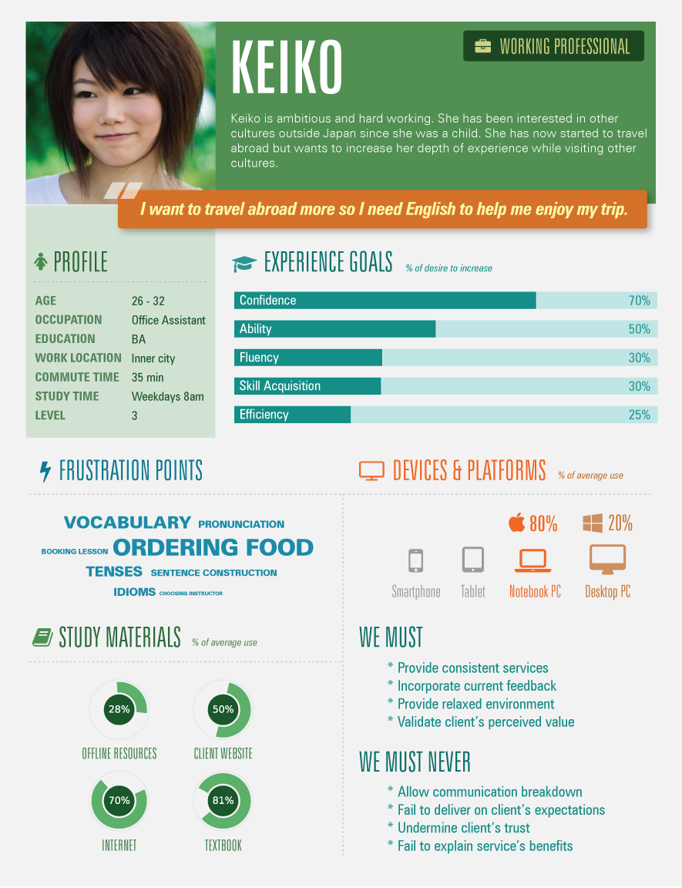

# Conclusion (~100 words)

* Reflection on what you learned
* What are your next steps?

# Bibliography

Please include all your references. You can use [bibme.org](http://www.bibme.org/), [citethisforme.com](http://www.citethisforme.com/) or similar to help you with this.

# Appendix

## Interview Notes

If available, insert your interview notes here. If you have an audio clip of your interview, please insert a link to the audio clip. Remember to take consent of the person you are interviewing before recording them.

## Survey Results

If available, insert Survey Results here.